OOP EXPERIMENT-1

NAME-ANMOL SAP-590011794 BATCH-20
DATE-1 FEB 2026
SUBMITTED TO- PROF. Kalluri Shareef Babu

EX-2A
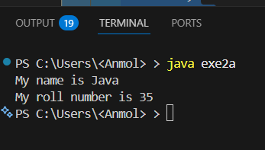
// constructor class student
{
String name; int roll;
void details()
{
System.out.println("My name is "+name); System.out.println("My roll number is "+roll);
}
}
public class exe2a
{
public static void main(String args[])
{
student s=new student(); s.name="Java"; s.roll=35;
s.details();
}
}
EX-2A
class Student
{
String name = "Java"; int roll = 35;
void details()
{
System.out.println("My name is " + name); System.out.println("My roll number is " + roll);
}
}
public class exe2b
{

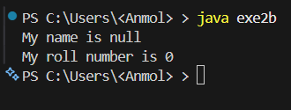
public static void main(String args[])
{
Student s=new Student(); s.details();
}
}
EXE-2C
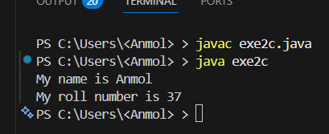
//Creating a class Student with attributes name and roll number class Student
{
String name = "Java"; int roll = 35;
void details()
{
System.out.println("My name is " +name); System.out.println("My roll number is " +roll);
}
}
public class exe2c
{
public static void main(String args[])
{
Student s=new Student(); s.name="Anmol"; s.roll=37;
s.details();
}
}

EXE-2D
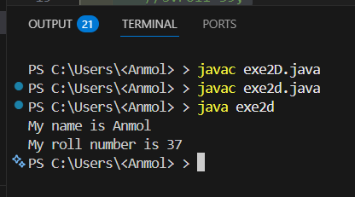
class Student
{
private String name = "Java"; private int roll = 35;
void details()
{
String name ="Anmol"; int roll =37;
System.out.println("My name is " +name); System.out.println("My roll number is " +roll);
}
}
public class exe2d
{
public static void main(String args[])
{
Student s=new Student();
//s.name="Damn";
//s.roll=39; s.details();
}
}
EXE-2E
class Student
{
private String name ="Java"; private int roll =35;
void details()
{
System.out.println("My name is " +name); System.out.println("My roll number is " +roll);
}
}

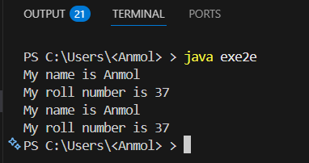
public class exe2e
{
public static void main(String args[])
{
Student s1=new Student(); s1.details();
Student s2=new Student();
//s2.name="Anmol"; causes error
//s2.roll=37; causes error s2.details();

}
}
EXE-2F
class Student
{
private String name; private int roll ; Student()
{
name="Java"; roll=35;
}
void details()
{
System.out.println("My name is " +name); System.out.println("My roll number is " +roll);
}
}
public class exe2f
{
public static void main(String args[])
{
Student s1=new Student(); s1.details();
}

}
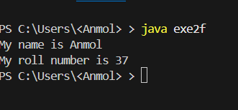
EXE-2G
class Student
{
private String name; private int roll ; Student()
{
name="Java"; roll=35;
}
Student(String s,int n)
{
name=s; roll=n;
}
void details()
{
System.out.println("My name is " +name); System.out.println("My roll number is " +roll);
}
}
public class exe2g
{
public static void main(String args[])
{
Student s1=new Student(); s1.details();
Student s2=new Student("Anmol",37); s2.details();
}
}

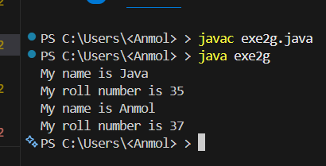
EXE-2H
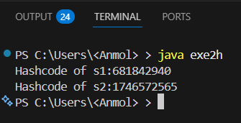
//print hashcode of two objects class stu
{
String name; int roll;
}
public class exe2h
{
public static void main(String args[])
{
stu s1=new stu(); stu s2=new stu();
System.out.println("Hashcode of s1:"+s1.hashCode()); System.out.println("Hashcode of s2:"+s2.hashCode());
}
}

